**📊 Power BI Visualization - Day 07 and Day 08**

## DAY 07: 10 JULY 2025

* This document serves as a hands-on guide to building various types of visualizations using **Power BI Desktop**, based on real-world datasets like **Sample Superstore** and **India Population Data**.
* Over the course of **Day 07 and Day 08**, multiple chart types were explored—from simple bar charts to advanced visuals like **Gauge, Ribbon, Waterfall, Tree Maps, and Line & Column charts**.

**Step 1 : Download Power BI Desktop from Microsoft Store.**

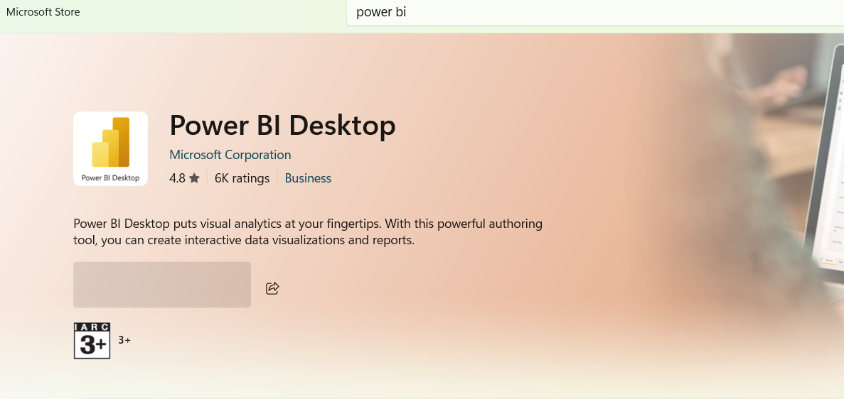

**Step 2 : Load xlsx file in power bi.**

**Download Sample Superstore file:** [**Click here**](https://docs.google.com/spreadsheets/d/1T5smhzZB4v4B9VDRn0EeTu33Pxls9D5J/edit?usp=drive_link&ouid=110546095688260364412&rtpof=true&sd=true)

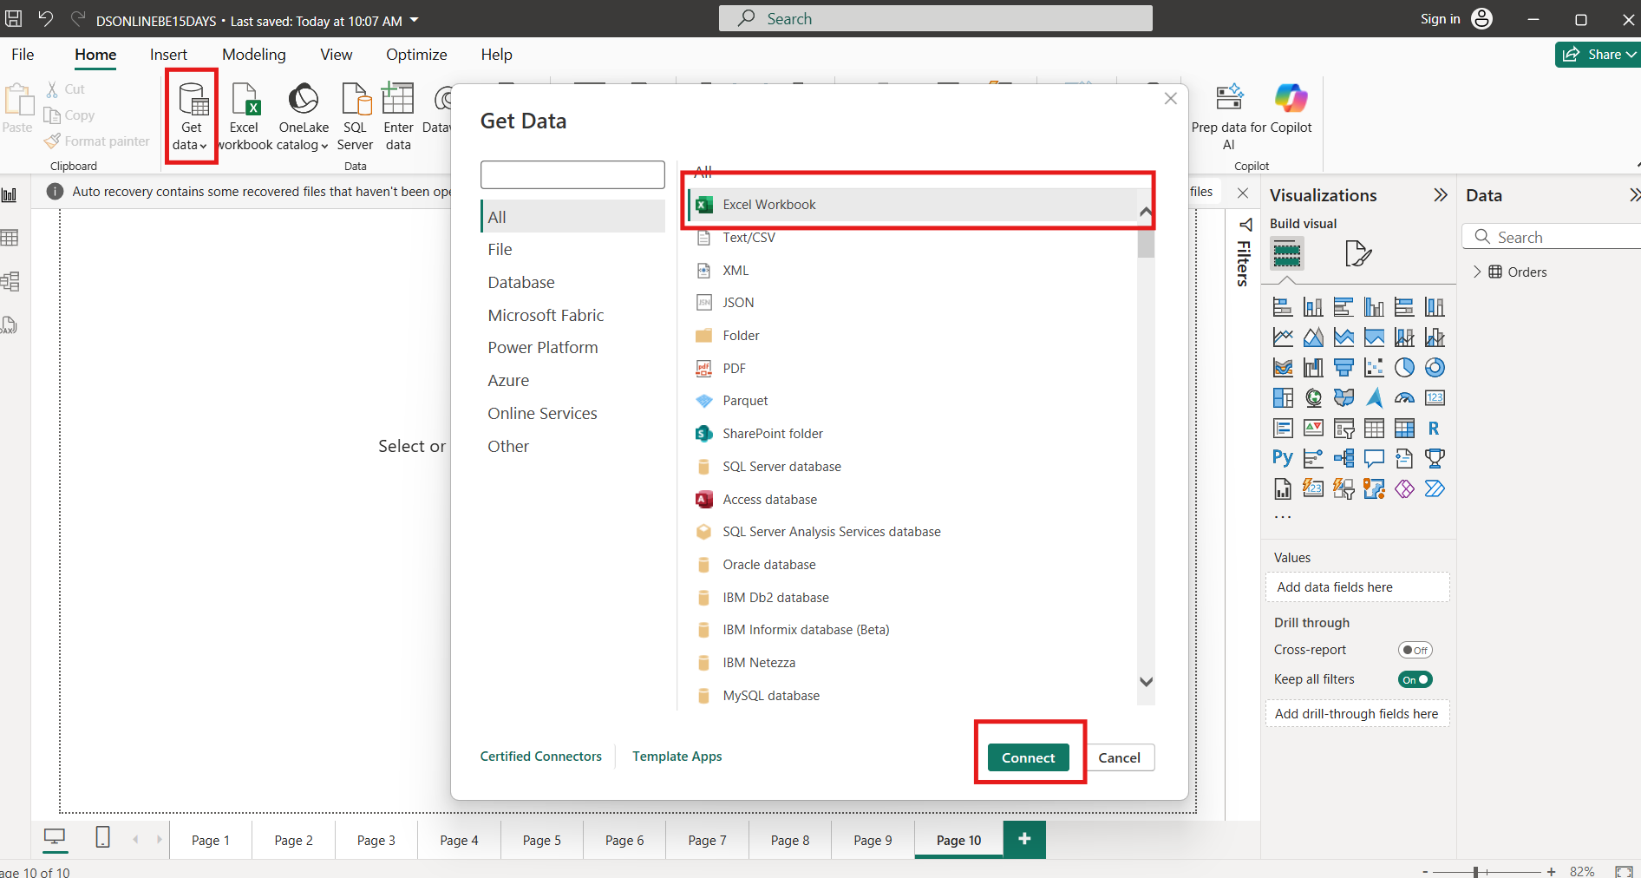

1. **Create Visuals For Bar Chart:**
   1. Select Bar Chart From Visuals
      1. X Axis - Category
      2. Y Axis - Sales

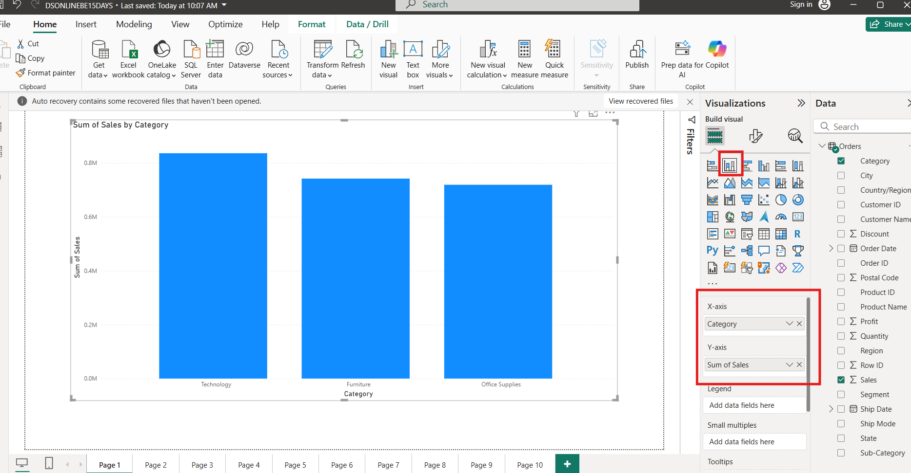

1. **Create Visuals For Bar Chart:**
   1. Select Bar Chart From Visuals
      1. X Axis - Sub Category
      2. Y Axis - Sales

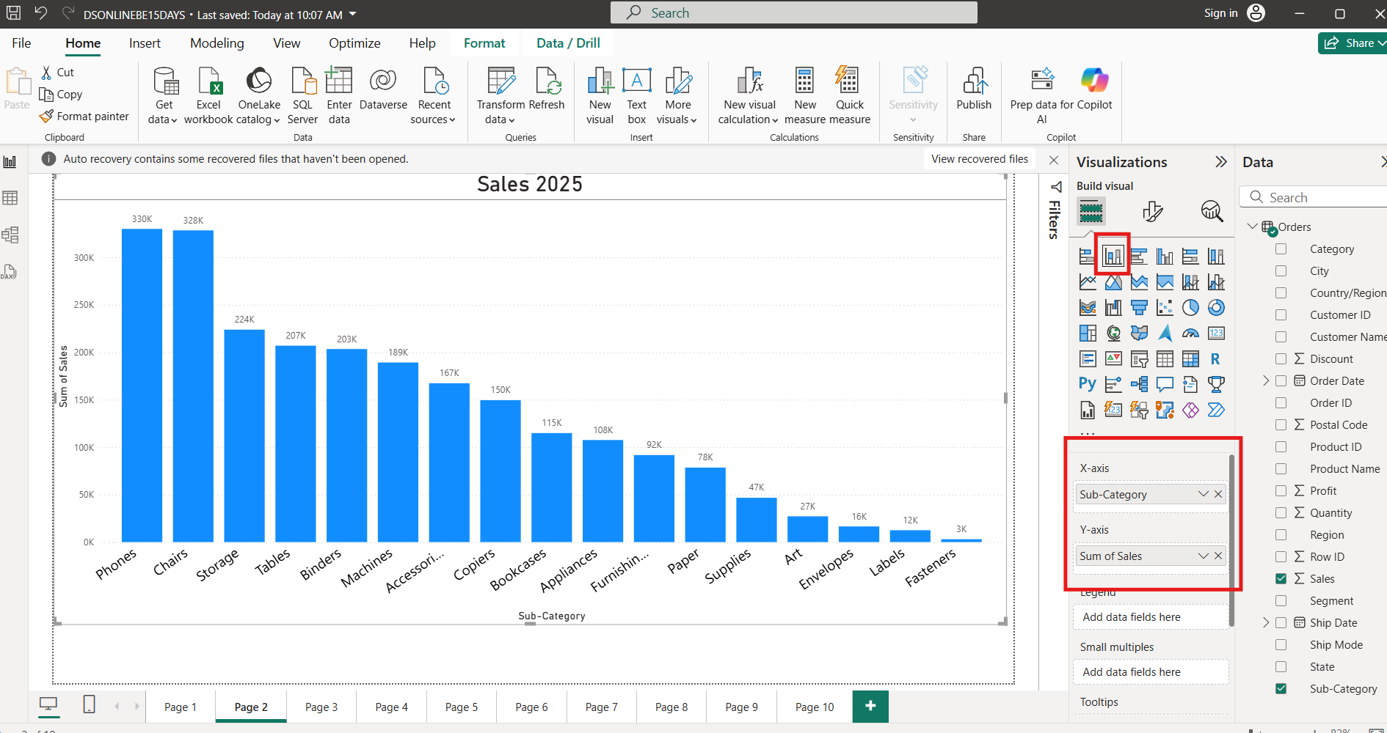

1. **Create Visuals For Pie Chart:**
   1. Select Pie Chart From Visuals
      1. Legend : Region
      2. Values: Sales

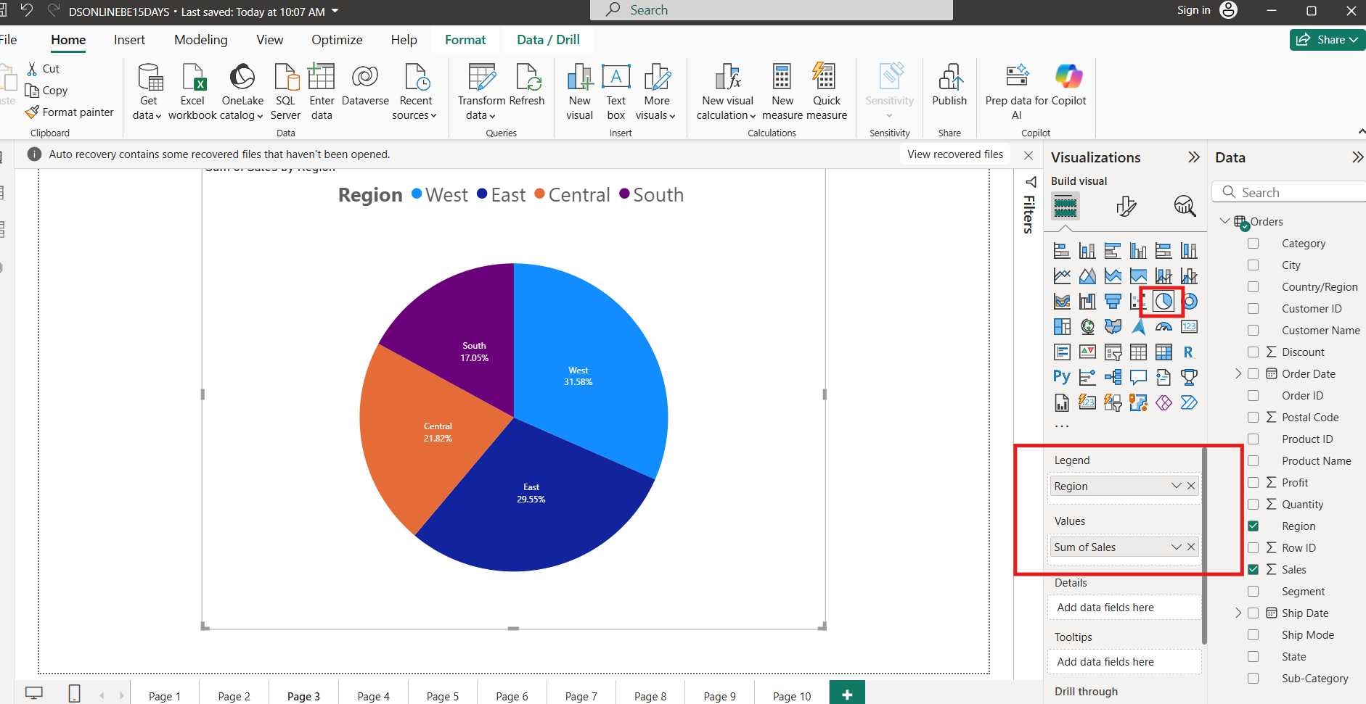

1. **Create Visuals For Donut Chart:**
   1. Select Donut Chart From Visuals
      1. Legend : Sub Category
      2. Values: Sales

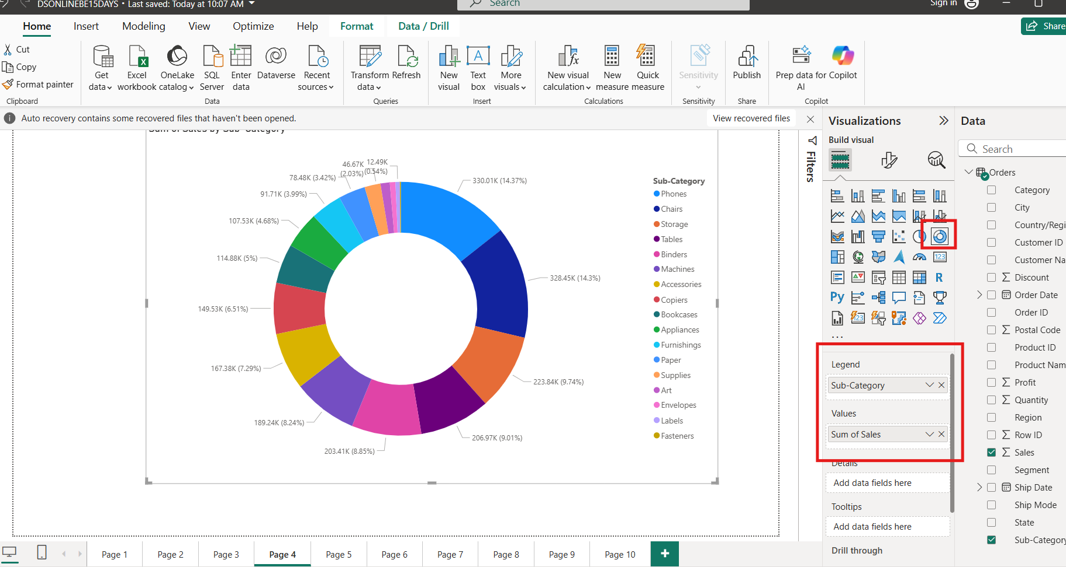

1. **Create Visuals For Line Chart:**
   1. Select Line Chart From Visuals
      1. X Axis - Order Date
      2. Y Axis - Sales

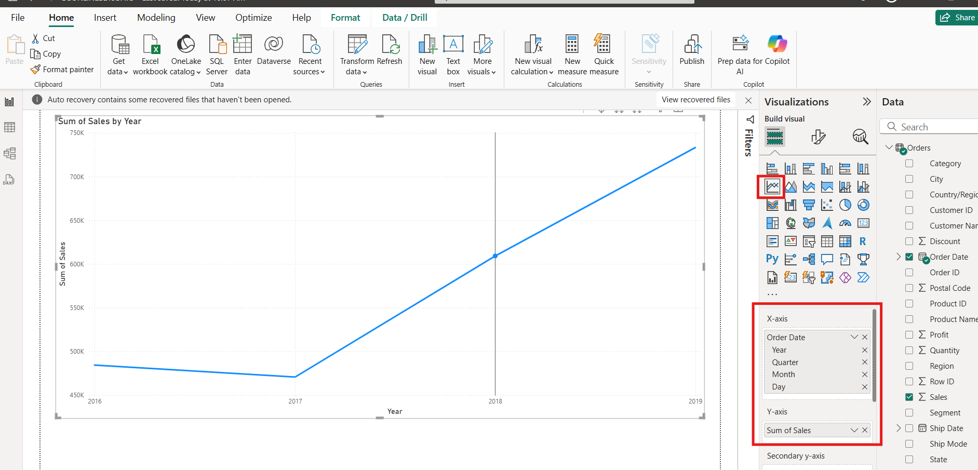

1. **Create Visuals For Stack Bar Chart:**
   1. Select Stack Bar Chart From Visuals
   2. X Axis - Sub Category
   3. Y Axis - Sales

**Legend - Region**

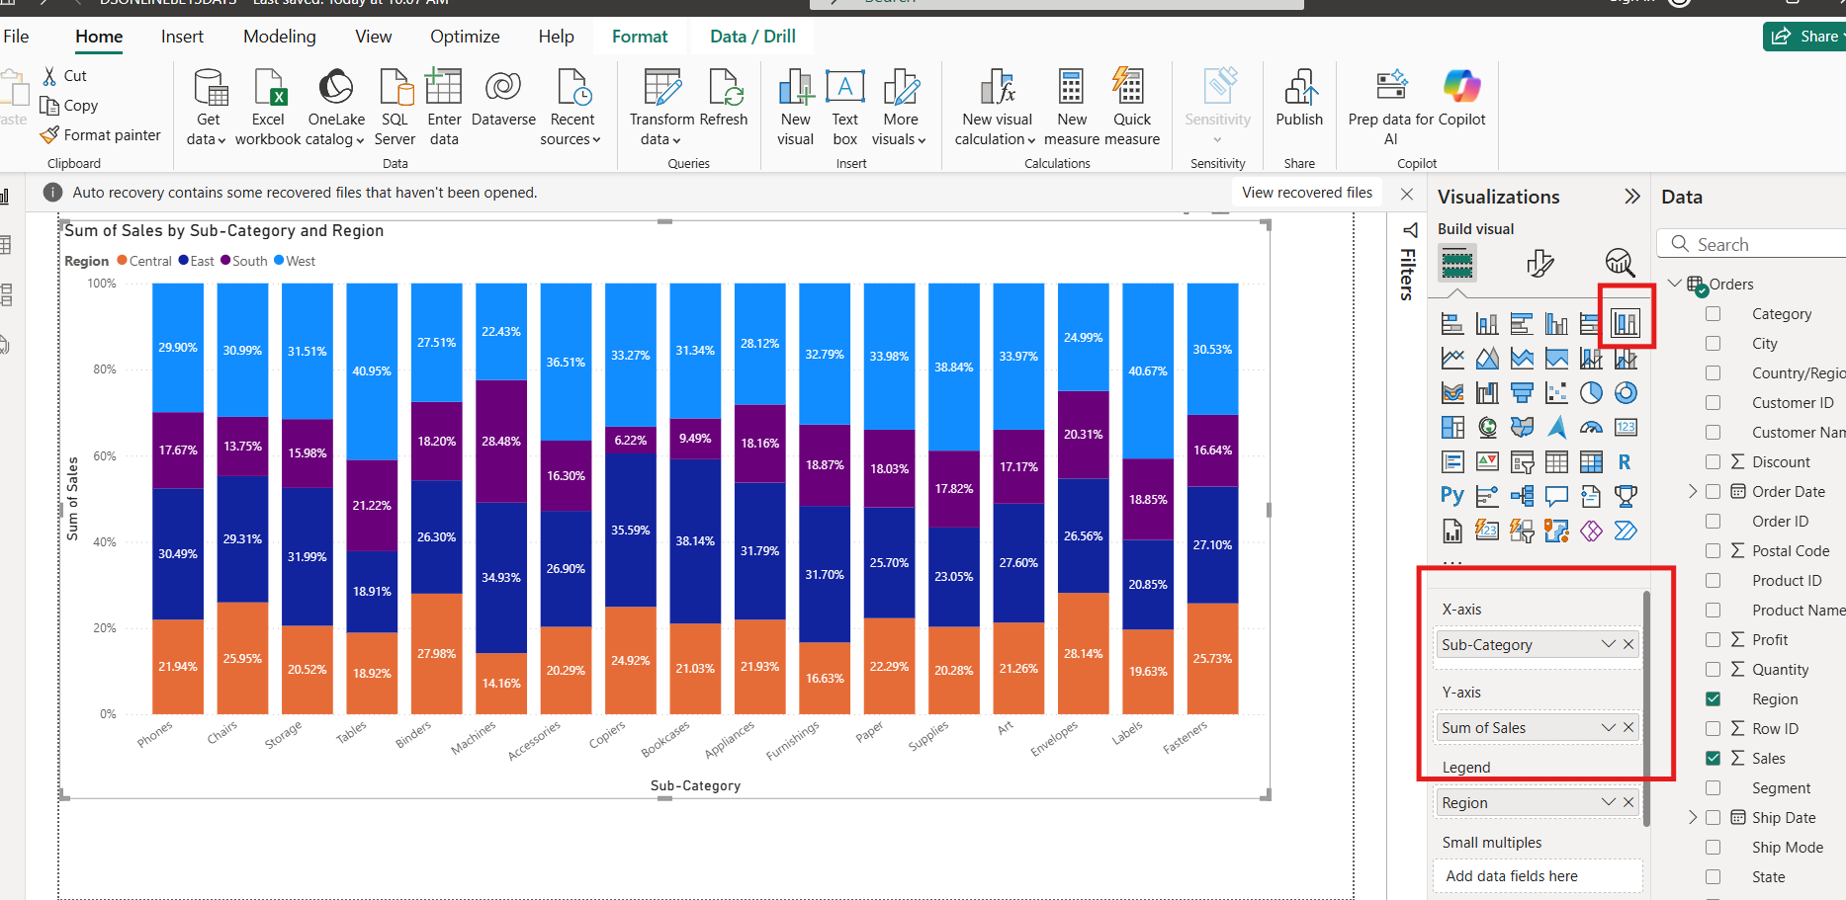

1. **Create Visuals For Funnel Chart:**
   1. Select Funnel Chart From Visuals
      1. Category : Sub-Category
      2. Values: Profit

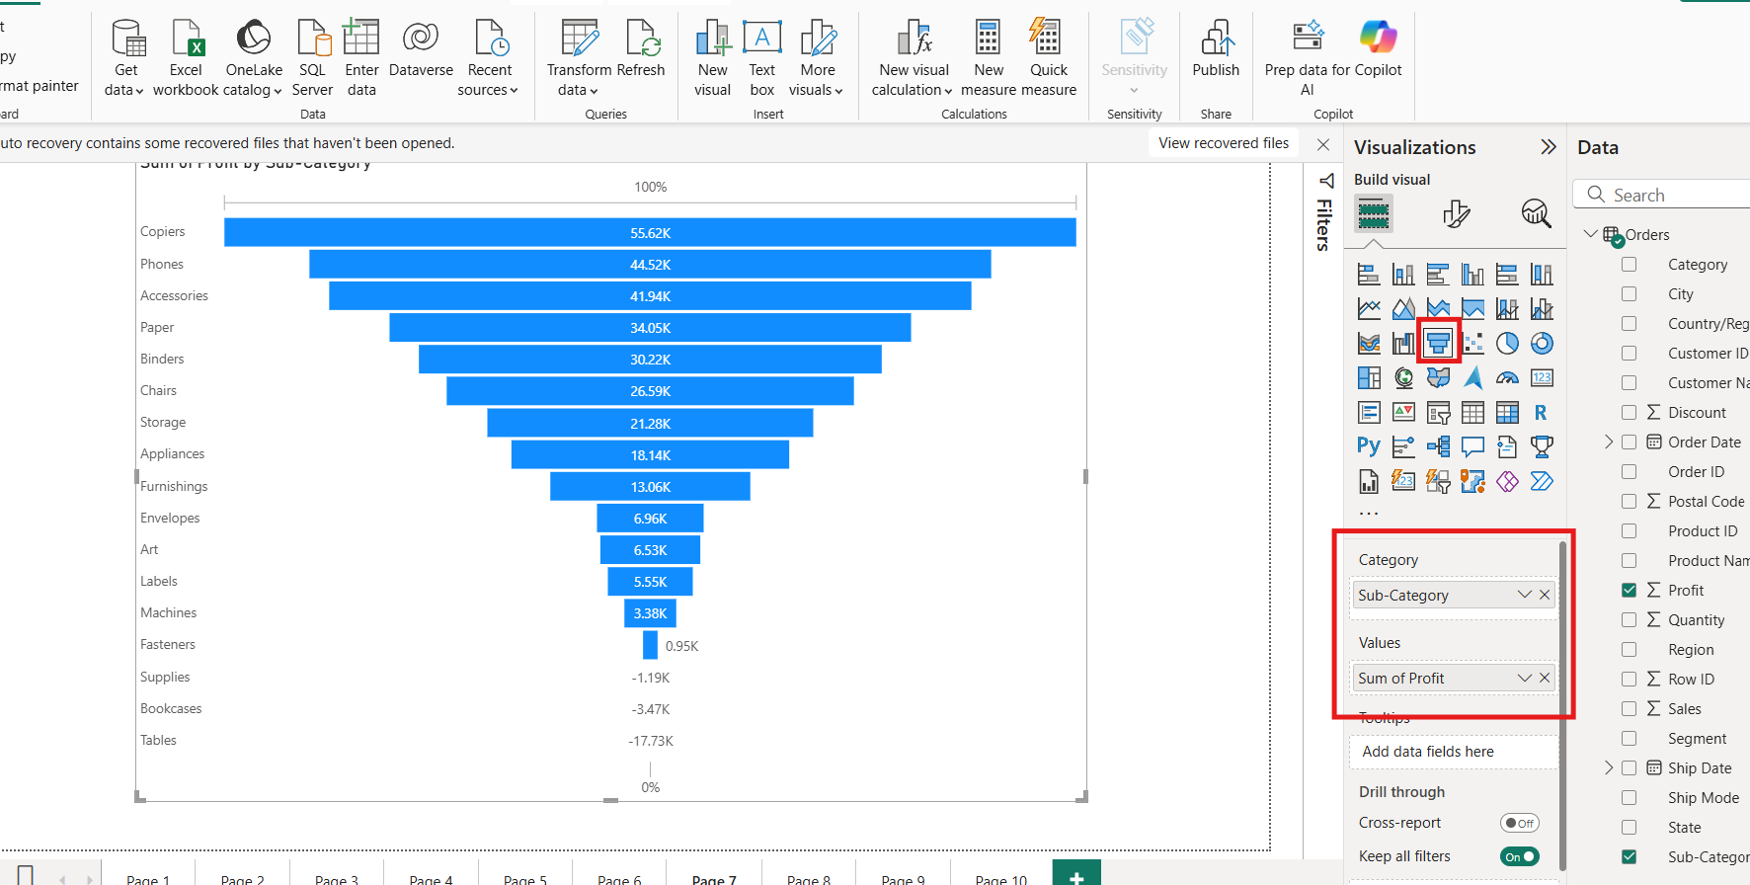

1. **Create Visuals For Ribbon Chart:**
   1. Select Ribbon Chart From Visuals
      1. X Axis - Order Date
      2. Y Axis - Sales

**Legend - Region**

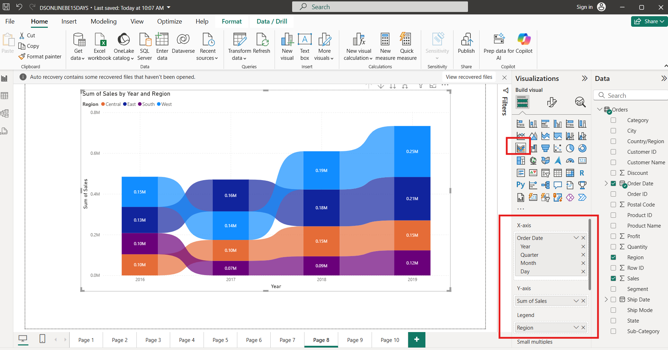

1. **Create Visuals For Map Chart:**
   1. Select Map Chart From Visuals
      1. Location: State
      2. Legend – Category\

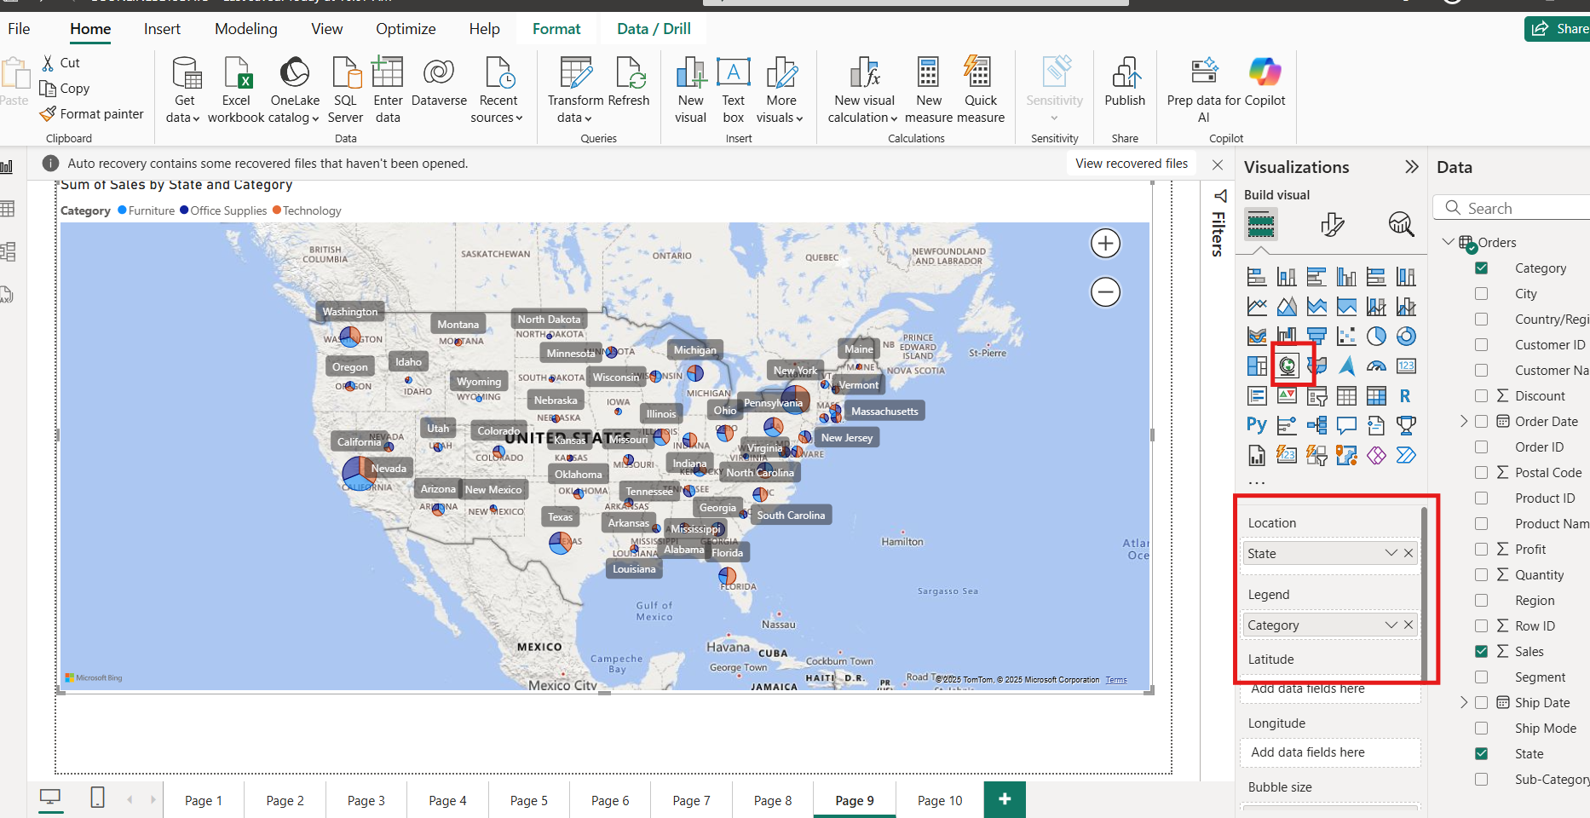

## DAY 08: 11 JULY 2025

Download India xlsx file: [Click Here](https://docs.google.com/spreadsheets/d/1qIoPtGgDOgz58c5th16Oi9Zh0XzMW5ls/edit?usp=sharing&ouid=117834163679353941797&rtpof=true&sd=true)

1. **Create Visuals For Map Chart:**
   1. Select Map Chart From Visuals
      1. Location: State
      2. Legend – Population

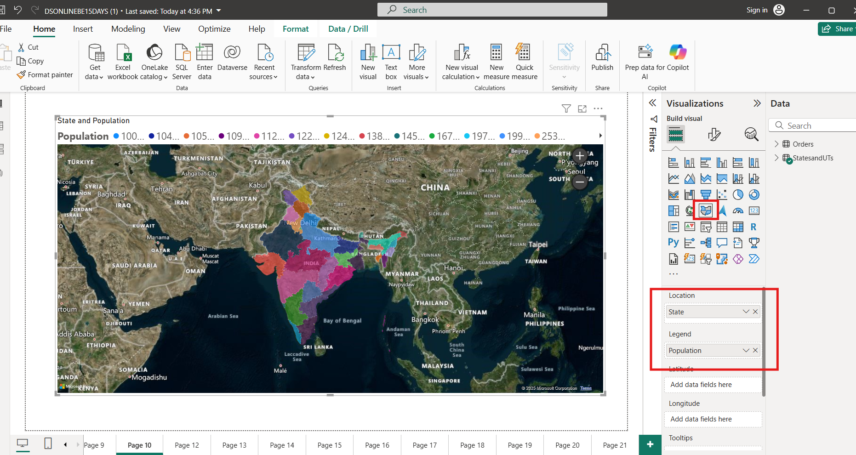

1. **Create Visuals For Table Chart:**
   1. Select Table Chart From Visuals
      1. Columns: subcategory , sales , profit , discount

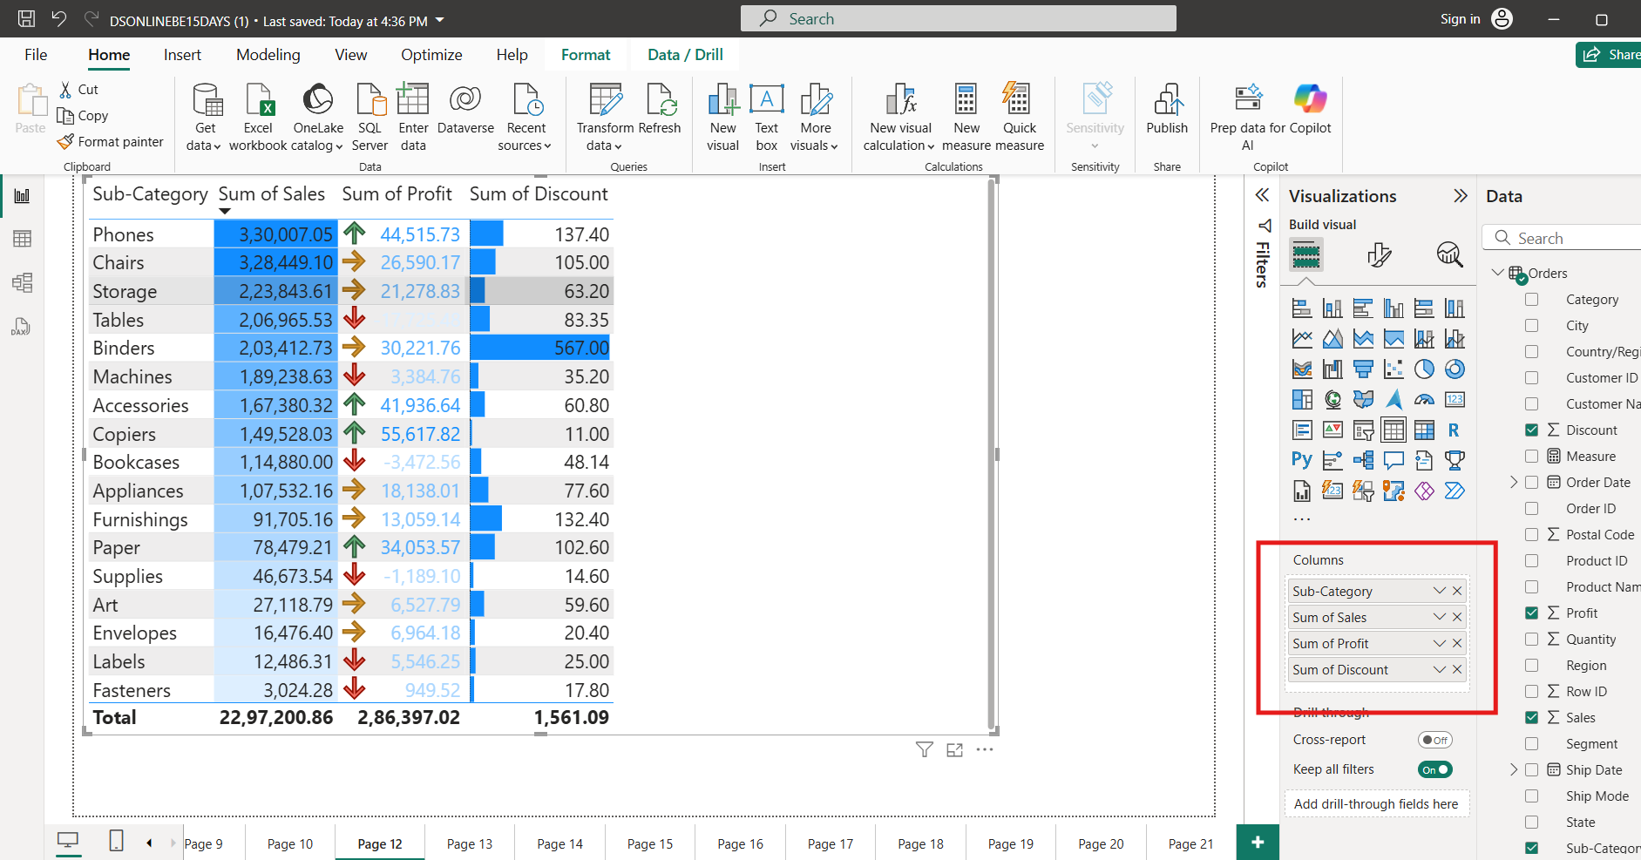

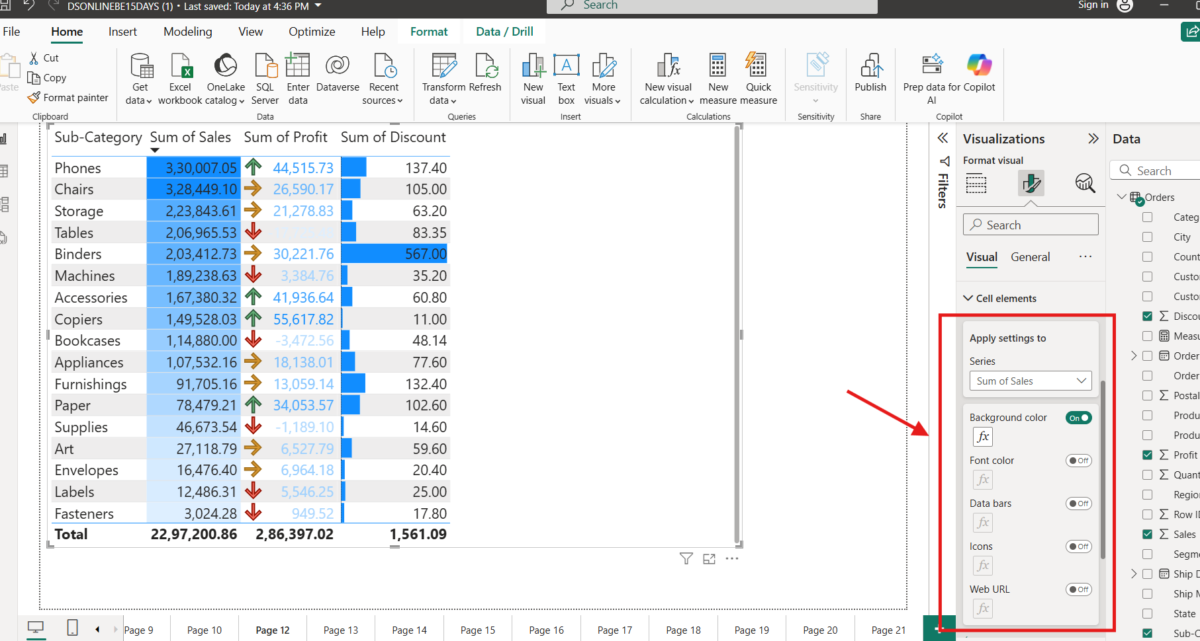

1. **Create Visuals For Matrix Chart:**
   1. Select Matrix Chart From Visuals
      1. Rows : Sub Category
      2. Columns : Order Date
      3. Values: Sales

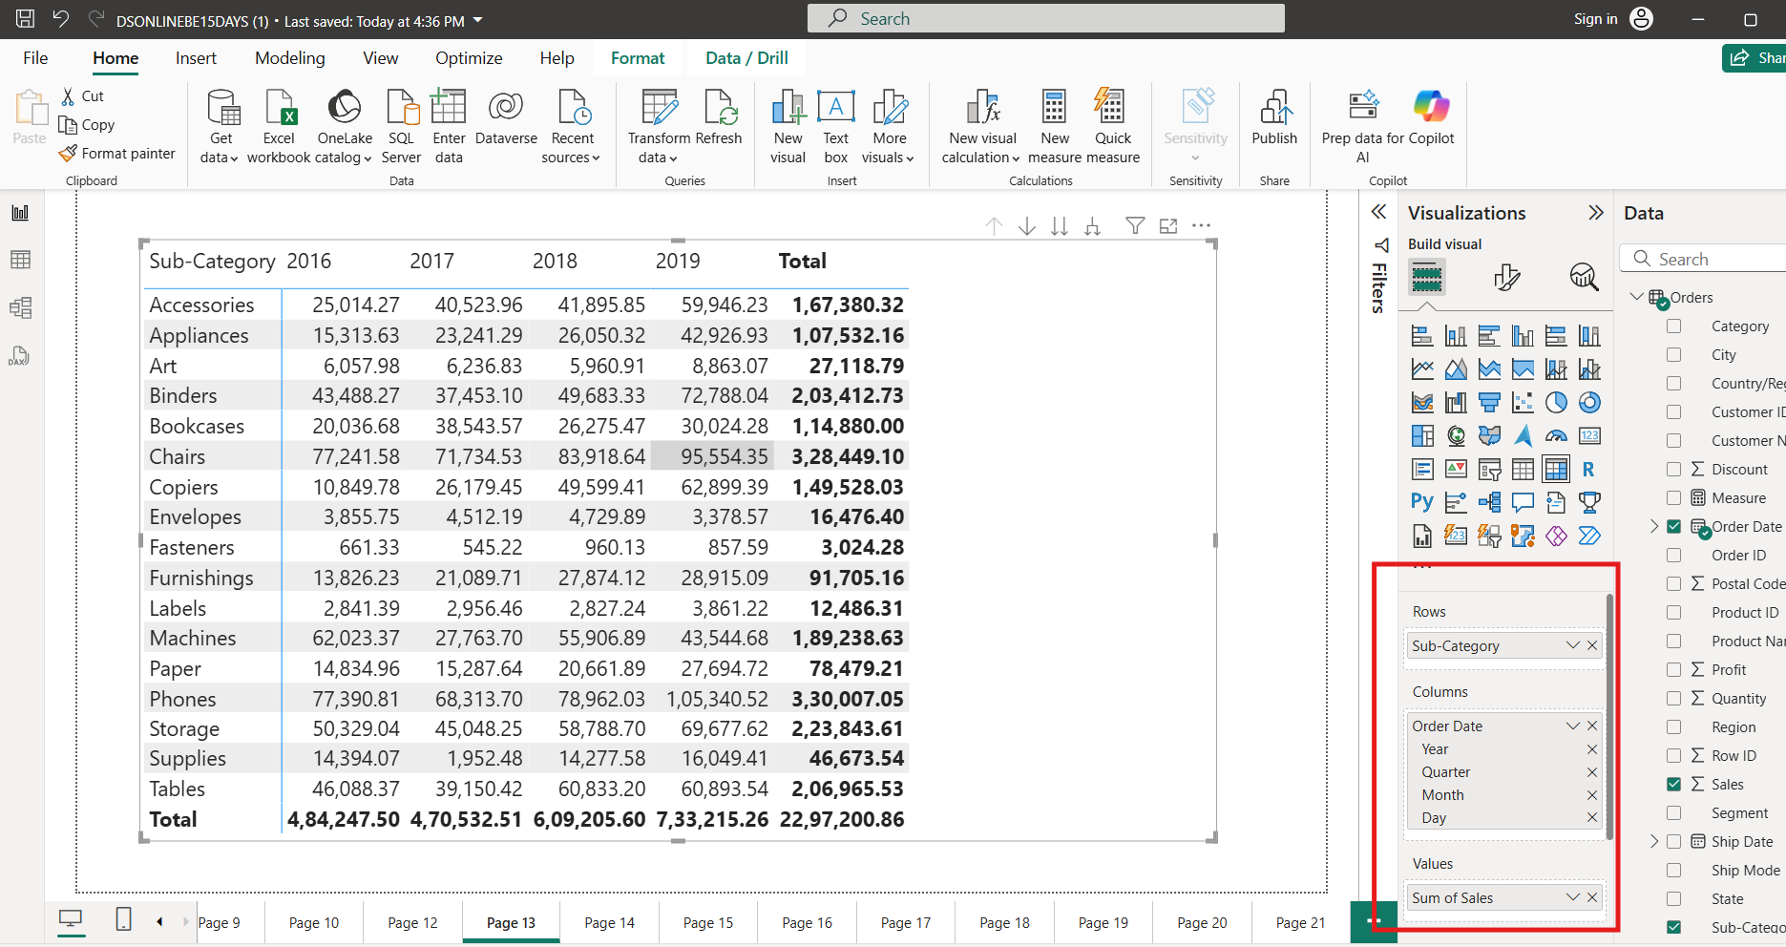

1. **Create Visuals For Area Chart:**
   1. Select Area Chart From Visuals
      1. X Axis : Order Date
      2. Y Axis : Profit
      3. Legend: Category

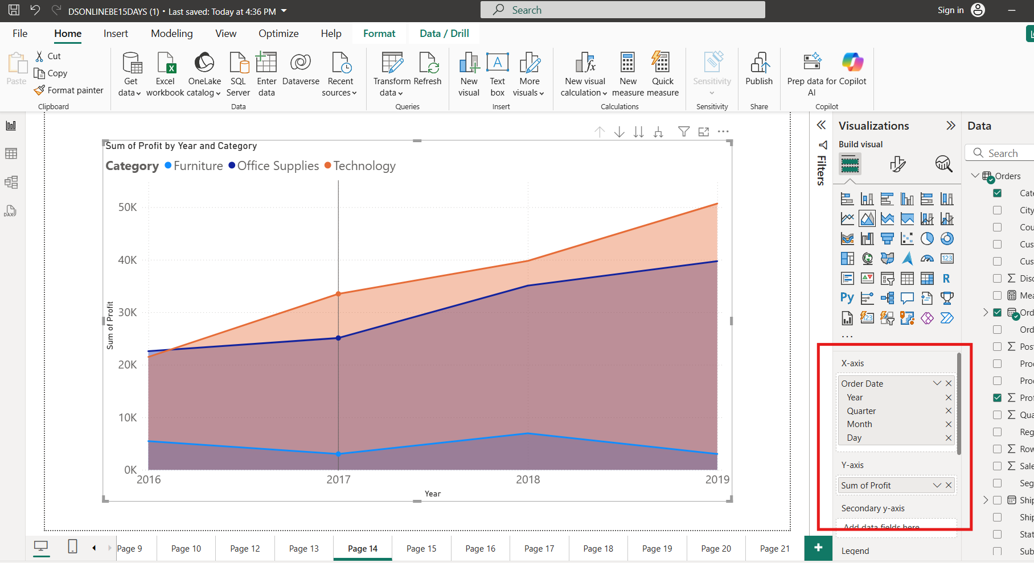

1. **Create Visuals For Line and Column Chart:**
   1. Select Line and Column Chart From Visuals
      1. X Axis: Order Date
      2. Column Y Axis- Sales
      3. Line Y Axis: Profit
      4. Small Multiple: Region

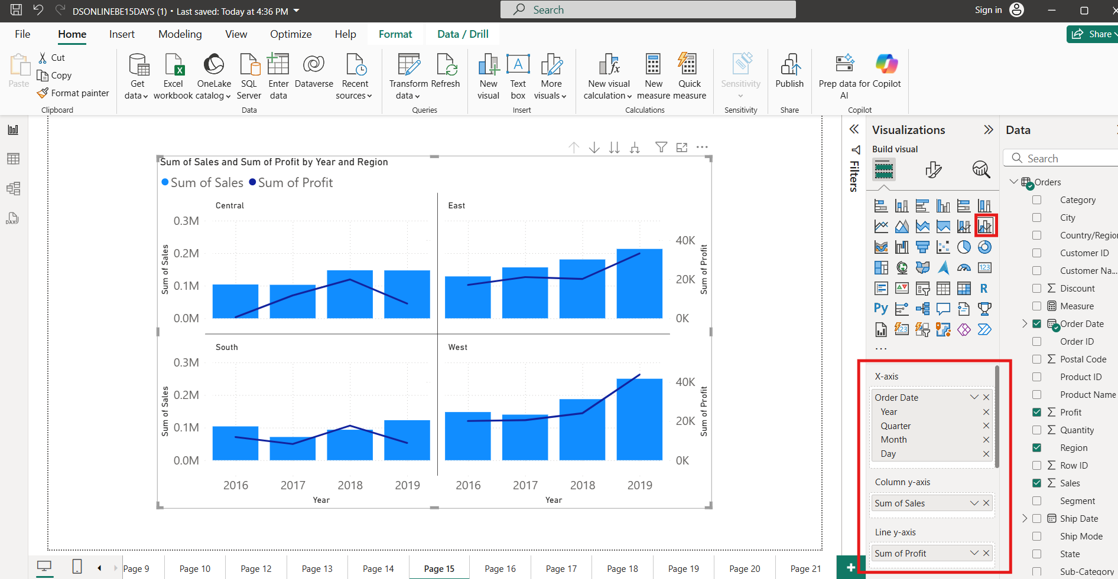

1. **Create Visuals For Scatter Chart:**
   1. Select Scatter Chart From Visuals
      1. Values: SubCategory
      2. X Axis: Sales
      3. Y Axis: Profit
      4. Legend: Category
      5. Size: Quantity
      6. Play Axis: Order Date ( Date Hierarchy )

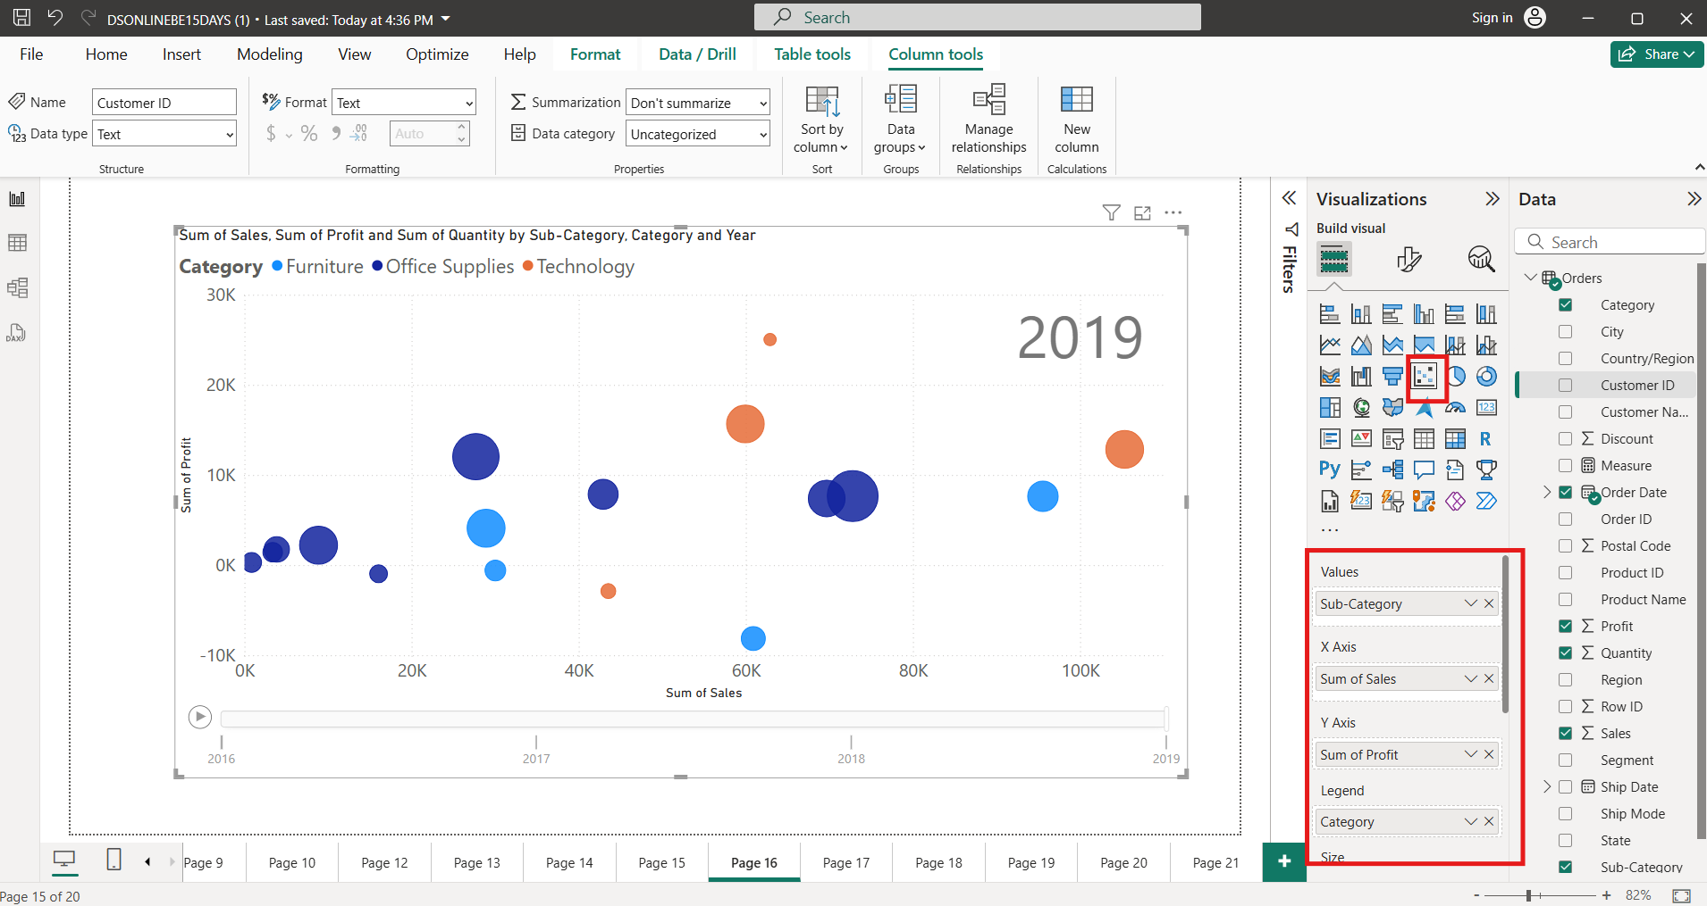

1. **Create Visuals For WaterFall Chart:**
   1. Select WaterFall Chart From Visuals
      1. Category: Order Date
      2. Breakdown: Region
      3. Y Axis- Sales

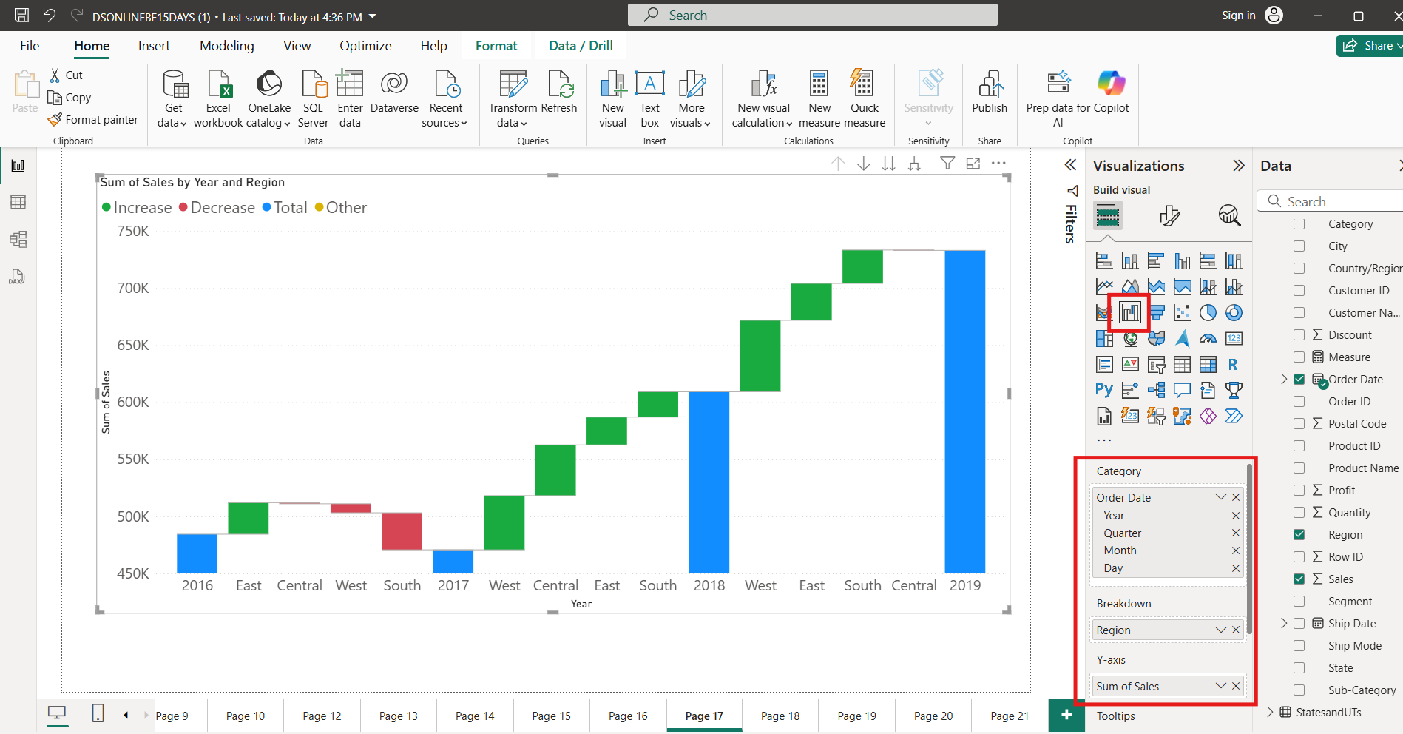

1. **Create Visuals For Tree Chart:**
   1. Select Tree Chart From Visuals
      1. Category: State
      2. Value- Profit

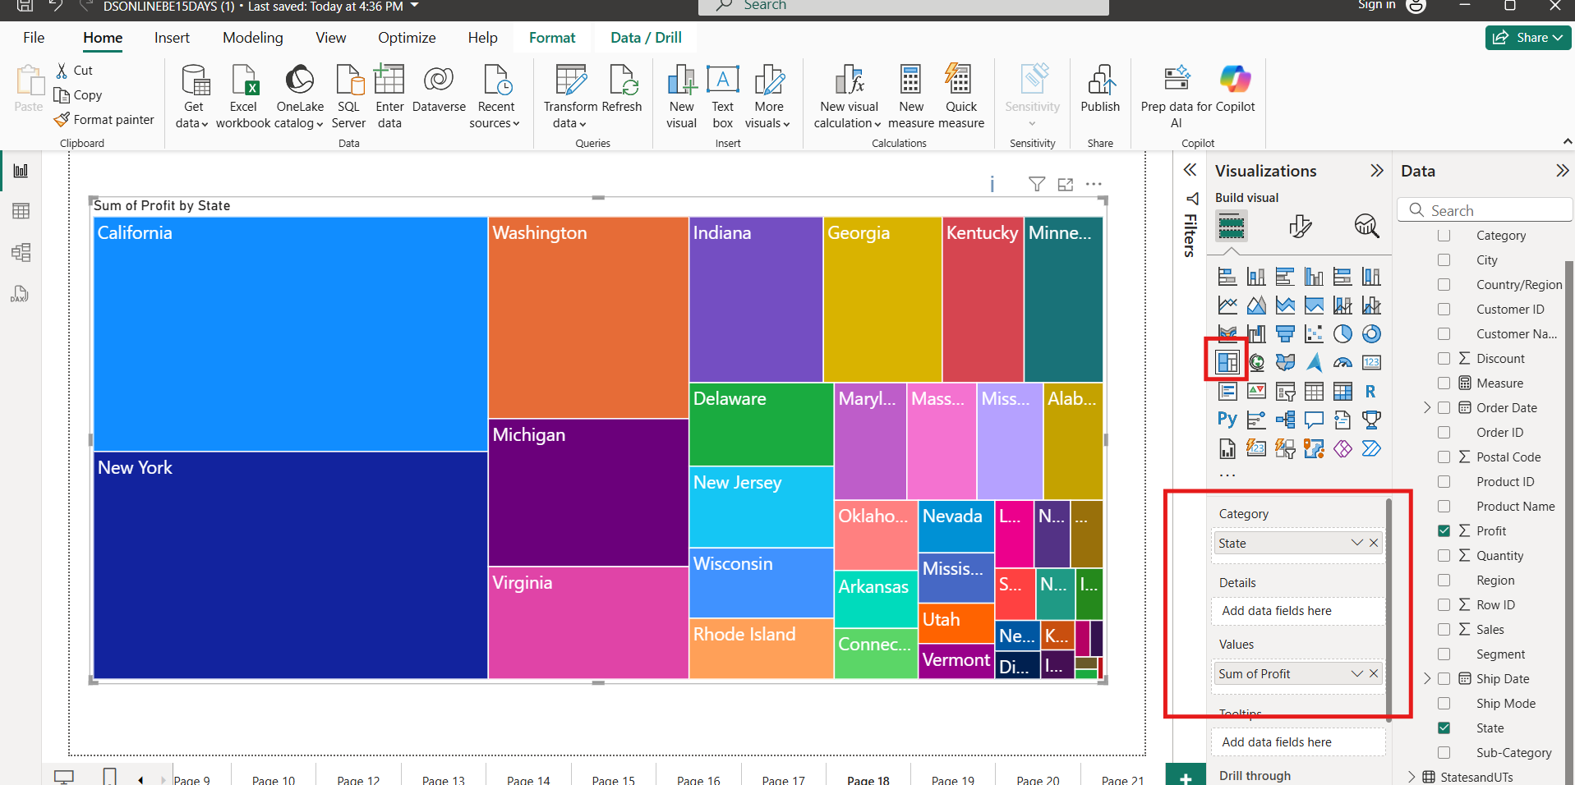

1. **Create Visuals For Tree Chart:**
   1. Select Tree Chart From Visuals
      1. Category: Subcategory
      2. Value- Sales
      3. Details: Region

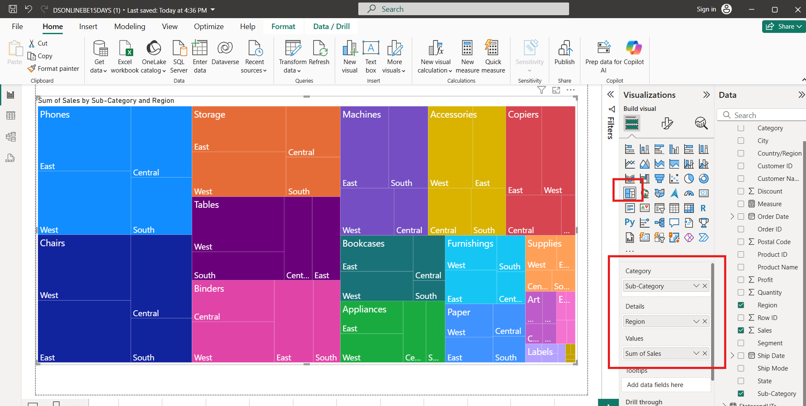

1. **Create Visuals For Gauge Chart:**

* **Create a new measure:**

**Measure = SUM(Orders[Sales])*1.2**

* 1. Select Gauge Chart From Visuals
     1. Value: Sales
     2. Target Value- Measure

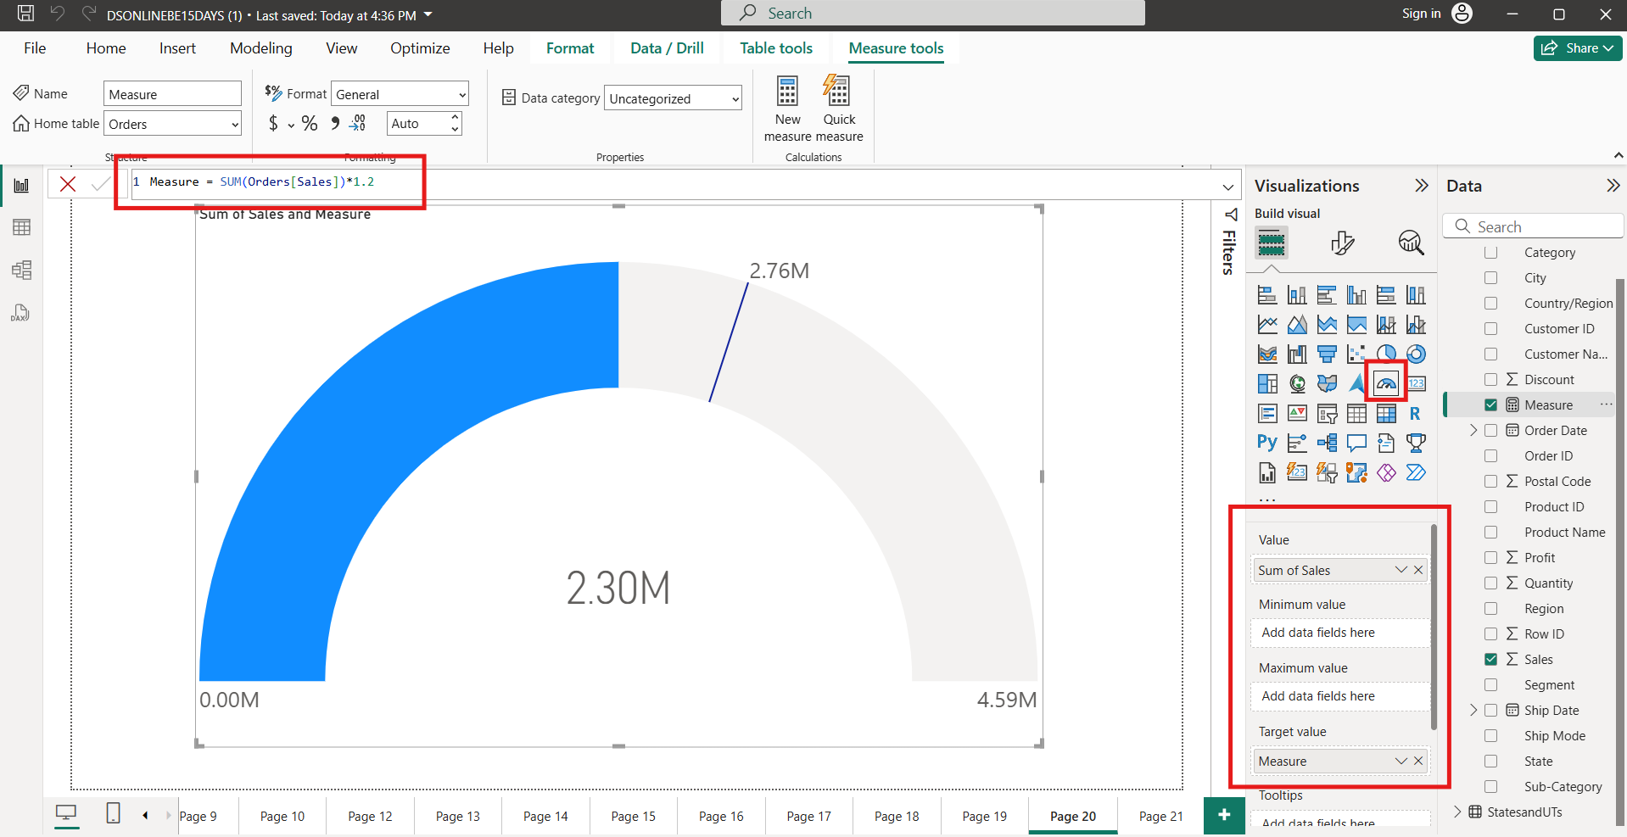

* 1. Select Pie Chart from Visuals
     1. Legend: Region
     2. Values: Sales

